Nebo registration

The description is made on 09/09/2018.

1. To register an account with the service, go to https://nebopro.ru/login.

2. Click on the link "No account yet".

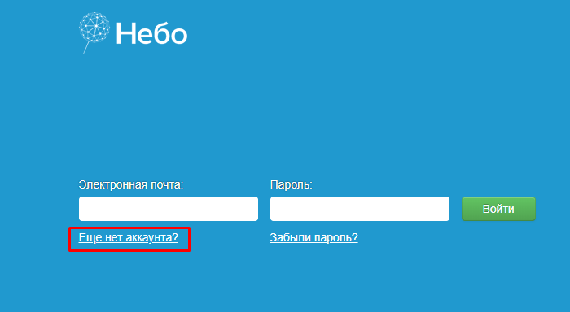

3. Fill in the required data and click the Register button.

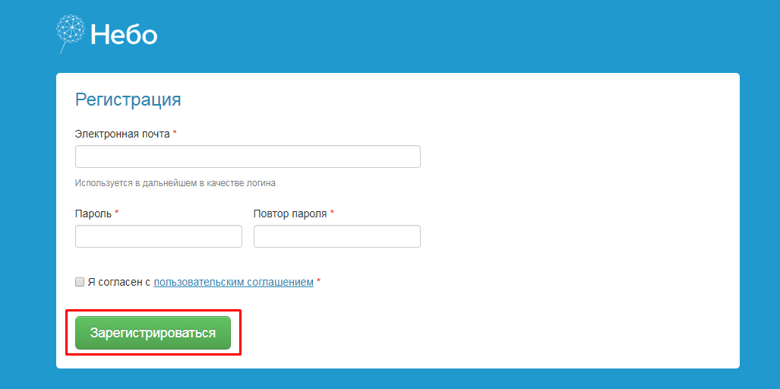

4. Complete the registration by filling out the additional data and clicking on the "Go to the next step" button.

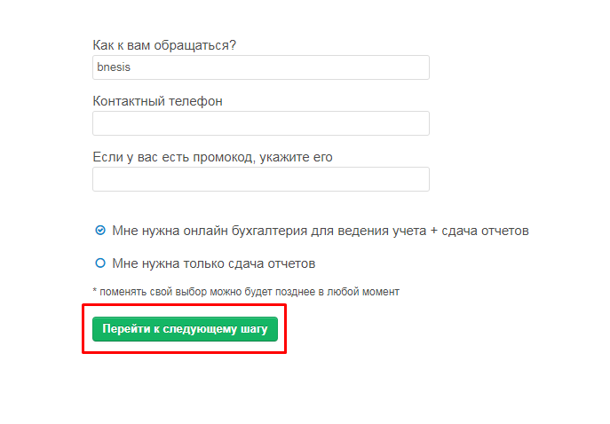

5. In the next window, select the type of organization and click on "Finish registration".

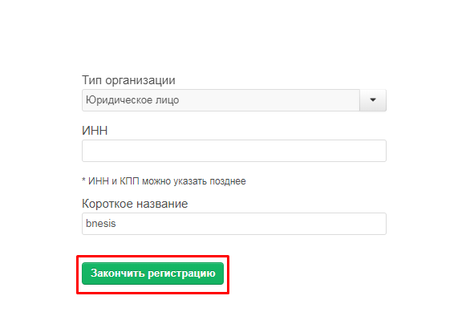

6. Then you can start the work. Your login and password are the keys required to use the API.

